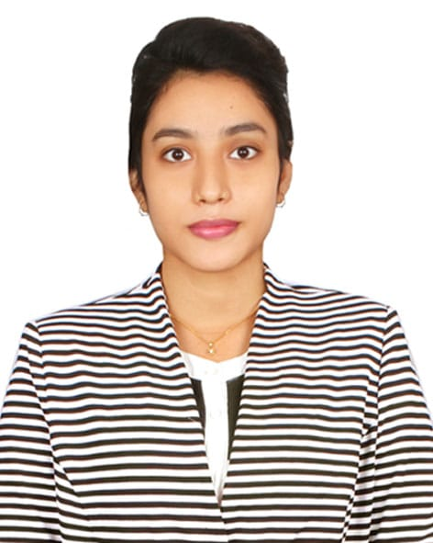

**Curriculam Vitae**

**Of**

**TASLIMA TANIA**

Permanent Address : village: Mohadevpur Thana: Mohadevpur

District : Naogaon Division: Rajsahi.

Contact Address : House#08, Road#19, Uttara , Dhaka.

Mobile : 01771820403

Email : chowdhurytania23@gmail .

Linkedin : https://www.linkedin.com/in/tania-chowdhury-374262215/

**PROFILE**

I am an energetic, ambitious person who has developed a mature and responsible approach to any task that I undertake, or situation that I am presented with. As a graduate with four years’ experience in English Department with many cultural activities, I am excellent in working with others to achieve a certain objective on time and with excellence.

**EDUCATION**

2022-2023 Master of Human Resource and Industrial Relations 4.65

Jahangirnagar university

2017-2021 Bacholor of English Language & Literature 4.76

Uttara University

2017 Higher Secondary School Certificate 5.87

Uttara High school

2015 Secondary school Certificate 5.09

Mollartake Udyan School and Collage

**KEY ACHIVEMENTS**

* Girls Guide
* Handball Champian
* BNCC
* Dean Award

**PROFESSIONAL EXPRIENCE**

Institute Name : Sristy center School and Collage

Designation : Assistant English teacher

Duration : March-2022-23(Still Now)

Institute Name : Wide Vision School & Collage

Designation : Assistant English teacher

Duration : Four Month.

Institute Name : Soft it Link

Designation : Telemarketing Executive

Duration : One Year

**THESIS EXPERIENCE**

* Organizing project-based operations : The interplay of content, context and social Processes
* The role of English as a global language

**KEY MANAGEMENT EXPERIENCE**

* Comprehensive Communication Skills
* Strong sense of accountability
* Project Management
* Responsibility
* Strong work ethic
* Critical Thinking
* Teamwork and Collaboration Target driven
* Self-motivated

**SKILL AND ATTRIBUTES**

* Strong verbal and written communication skills in English and Bengali;Understand and speak Hindi very well.

• Have advance ICT skills along with MSword, MSExcel, PPT.

**REFEREES**

Monir Hossain

CCN Science and technolgy university department of English

01733-873084

Aminul Haque

Associate professor at Uttara University department of English

01712331031